**Wireframe Document**

**Heart Disease Diagnostic Analysis**



**Revision Number - 1.1**

**Last Date of Revision - 26/12/2021**

**Bhushan Patil**

1. **Kind of sample Population do we have**

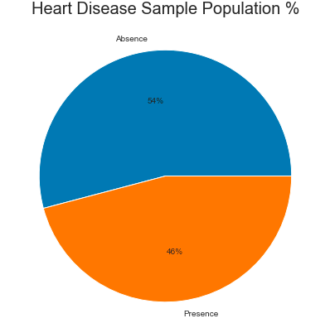

**-> As we see 46% of people are suffering from Heart Disease.**

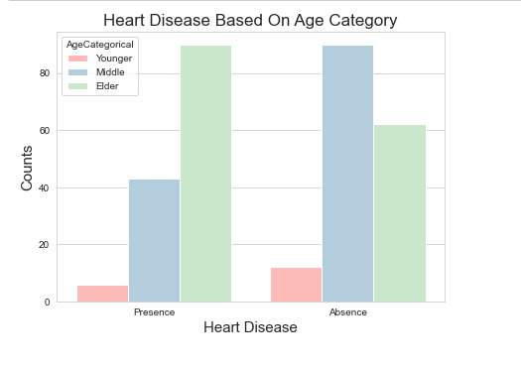

**-> As we see Elder people are more prone to Heart Disease.**

1. **Heart Disease based on Gender.**

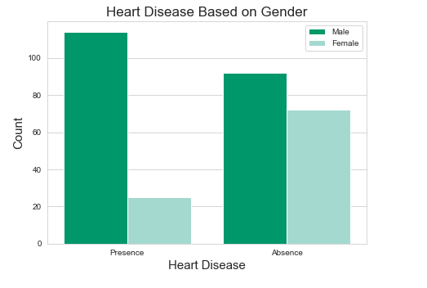

**-> Male are more prone to Heart Disease compared to females.**

1. **Chest Pain Experience by People.**

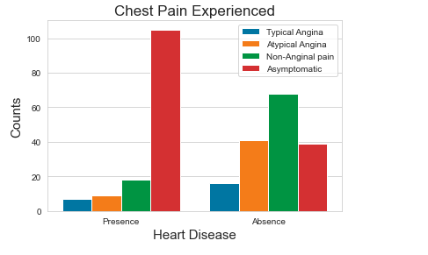

**-> As we can see, the people suffering from Heart Disease have Asymptomatic pain.**

**-> Also we can see if people have Asymptomatic pain that doesn't mean people suffer from Heart Disease.**

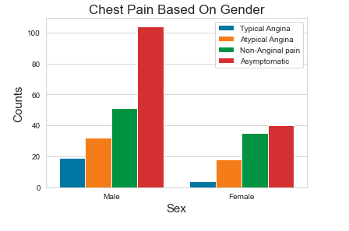

**-> We can see that a higher number of men are suffering from Asymptomatic Chest Pain.**

1. **Symptoms experienced by Heart Disease.**

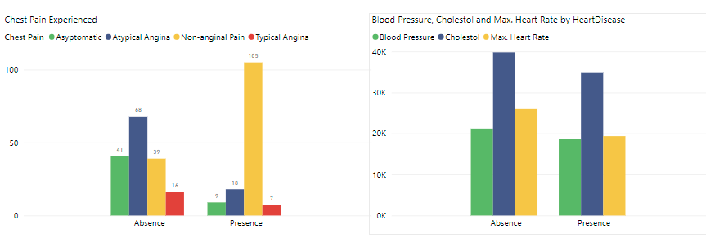

**-> It seems people having asymptomatic chest pain have a higher chance of heart disease.**

**-> Asymptomatic Chest pain means neither causing nor exhibiting symptoms of heart disease.**

-> **There seems to be a high number of cholesterol levels in people having heart disease.**

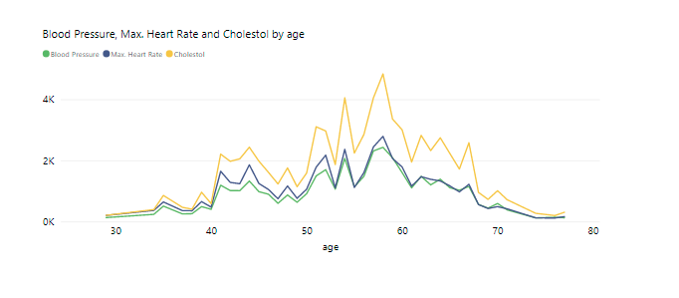

**-**> **Here we can observe that Blood Pressure increases between age of 50 to 60 and somehow continues the pattern till 70.**

**-> Similarly, Cholesterol and maximum heart rate increase in the age group of 50-60.**

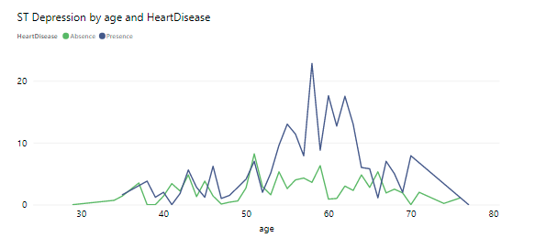

-> As we can see that ST depression increases in the age between 30-40.

